

Assessment Cover Page
Sumi Heo

2026324
Assessment Title
CA1 Capstone-strategic thinking
Lecturer/Supervisor
Muhammad lqbal
Assessment Due Date
26/10/2026
Date of Submission
26/10/2026
Use of AI Tools
Choose the statement that fits your work and delete the other.
I acknowledge the use of Gemini for the purpose of getting additional idea for my project.
I have not used any AI tools or technologies in the preparation of this assessment.
Declaration
By submitting this assessment, I confirm that I have read the CCT policy on academic misconduct and understand the implications of submitting work that is not my own or does not appropriately reference material taken from a third party or other source.
I declare it to be my own work and that all material from third parties has been appropriately referenced.
I further confirm that this work has not previously been submitted for assessment by myself or someone else in CCT College Dublin or any other higher education institution.

Contents
1.Project Title 4
2. Introduction 4
3. Problem Definition
3-1. Problem Definition 4
3-2. Excerpt 5
4. Aim and Objectives 1
5. Scopes 1
6. Methodology 1
7. Data Sources 1
8. Expected Deliverables 1
9. Project Timeline
9-1. Gantt Chart 1
10. Ethical and Legal Considerations 1
11. Appendix 2
11-1. Excerpt 3
11-2. AI 3
12. References 2

Project Title

Which house can get an economical benefit by installing solar PV in Ireland?

Introduction
This project focuses on creating a data-driven decision-support tool to help determine whether installing solar panels (PV) is economically valuable for houses in Ireland. As energy costs, such as electricity bills, increase, interest in renewable energy is growing. It is leading to increased demand for solar panel installations. From that perspective, this project will provide personalized recommendations that are easy to understand for people considering solar panel installation, moving beyond the binary logic of installation costs or cost savings.

Problem Definition

Problem Definition
In other words, this project begins with concerns which households can gain a reasonable economic benefit from installing solar thermal systems. Ireland does not receive a large amount of sunlight annually as UK. Annual sunlight levels also vary greatly. As attached in the appendix below, we can see that while there is a fair amount of sunlight in summer, in winter, especially from December to February, the amount is less than 100 hours per month. Nevertheless, the proportion of solar installations is increasing every year. To clarify whether this is financially valuable even in this condition I plan to conduct an analysis by county of Ireland. In addition, the reason it is difficult to compare installation costs with future electricity savings is that the results vary depending on location, system size, roof condition, electricity consumption, export payments, etc. Recommendations based on the BER rating, location, PVGIS allow people to get information about estimated annual savings, investment payback periods, estimated annual power generation and net present value (NPV).

Excerpt
https://energyefficiency.ie/wp-content/uploads/2026/04/Residential-Solar-Panel-Report-2026.pdf?utm_source - Appendix
https://www.seai.ie/data-and-insights/seai-statistics/key-publications/energy-in-ireland?trk=article-ssr-frontend-pulse_little-text-block&utm_source (‘Solar PV generation was up 69% and ambient heat capture from heat-pumps was up 19% in 2024.’)
https://www.met.ie/cms/assets/uploads/2023/07/Irelands-Climate-Averages-1991_2020.pdf?utm_source (sunshine comparison from 1990 to 2020)
https://www.cso.ie/en/statistics/climate/sunshinebymeteorologicalweatherstation/?utm_source - Appendix
https://www.met.ie/annual-climate-statement-for-2025?utm_source
https://www.met.ie/annual-climate-statement-for-2024?utm_source (2025, 2024 annual climate report)

Aim and Objectives
Analyze and estimate economic value and suitability of installing solar panel in Ireland, support potential user's decision making by developing a Web-Based Decision Support System (DSS) which provides necessary information and recommendation.

Scope

Methodology

Data Sources
SEAI National BER Research Tool: Main dataset which includes important data such as BER rating, County name, Date of assessment, year of construction, etc. However, it contains more than 1 million rows and over 100 columns. It would make it hard to analyze, so I extracted most recent data from 2022- 2024 which is over 270,000 data.
European Commission Joint Research Centre PVGIS (In case): API-based solar PV generation estimates using location and system parameters. The "Annual Solar Radiation" column data, which I considered using in the main dataset, has too many missing values, so I plan to use this data if I feel that the data is needed during analysis. I will verify the availability of the data before use

Expected Deliverables

Project Timeline
Data Collecting | 26.06.14 - 26.10.30
Data cleaning and understanding | 26.10.15 – 26.11.18
Extract necessary columns | 26.10.16 – 26.11.06
Check more datasets if it is necessary (PVGIS) | 26.10.05 – 26.12.31
Data initial analysis | 26.11.09 – 27.01.01
ML modelling comparison and trial | 27.01.01 – 27.04.01
Model evaluation and modification | 27.04.01 – 27.04.23
Test, interpretation | 27.04.23 – 27.05.06
Complete and report on the project | 27.05.06 – 27.05.23

Gantt Chart
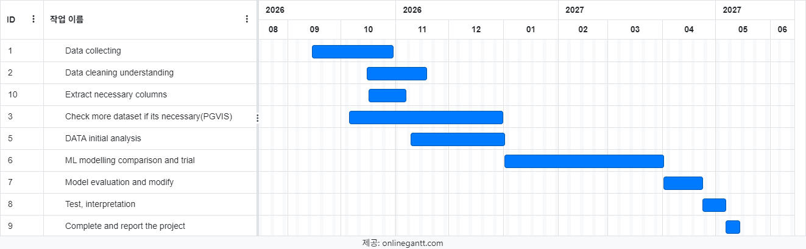

Ethical and Legal Consideration
I acknowledge that the BER dataset provided by SEAI includes location-related information (based on county) or real estate information. Only the necessary data will be used. Any data containing potentially sensitive personal details will be excluded from analysis. I have attached the SEAI, PVGIS terms, and all other sources used in the project in the references, and I will add them as needed. I do not collect any personal household data that is not necessary, and user inputs will not be retained in the prototype. Recommendations will clearly state that estimates depend on assumptions and are not guarantees. Also, I will inquire about availability before using the PVGIS data.

References
https://shop.solar-kit.eu/en/blog/post/solar-pv-meaning-capacity-and-net-present-value-explained-clearly
https://qbitsenergy.com/glossary/npv/
https://ndber.seai.ie/BERResearchTool/ber/search.aspx?utm_source
https://photovoltaic-geographic-information-system.ec.europa.eu/en European Commission Joint Research Centre PVGIS

Appendix

Excerpt
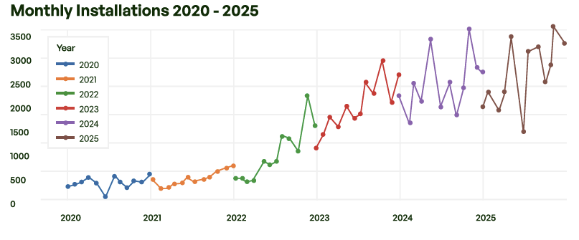
https://energyefficiency.ie/wp-content/uploads/2026/04/Residential-Solar-Panel-Report-2026.pdf?utm_source (monthly installation from 2020 to 2025)
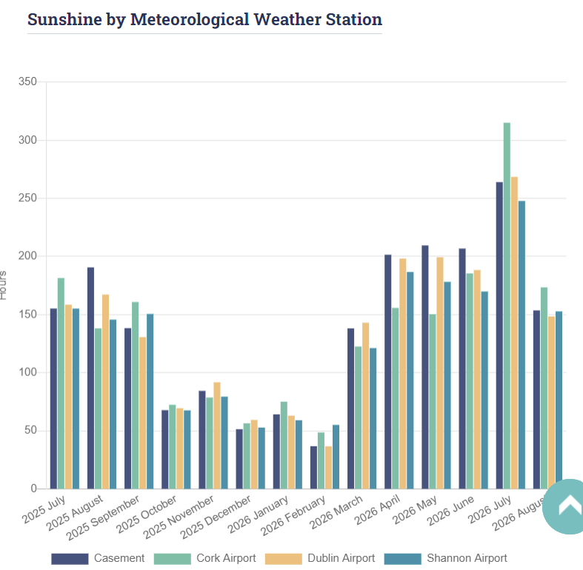https://www.cso.ie/en/statistics/climate/sunshinebymeteorologicalweatherstation/?utm_source(Total Sunshine per Month (Hours))

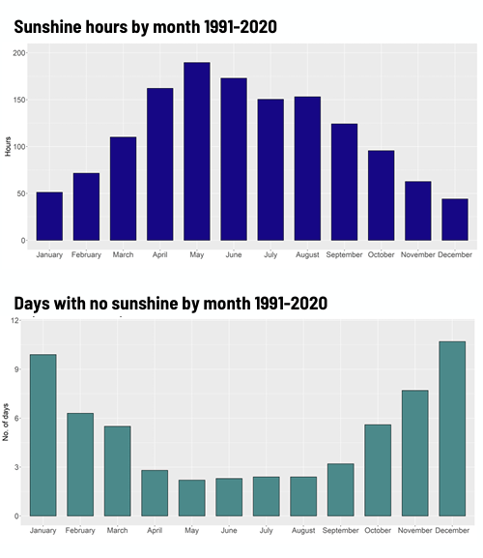https://www.met.ie/cms/assets/uploads/2023/07/Irelands-Climate-Averages-1991_2020.pdf?utm_source (sunshine comparison from 1990 to 2020)

AI 